IS Assignment 3
21K-3278
Task 1:
Creating the required directories and files. Adding a number to serial file.
Uncommenting unique_subject in .conf file.
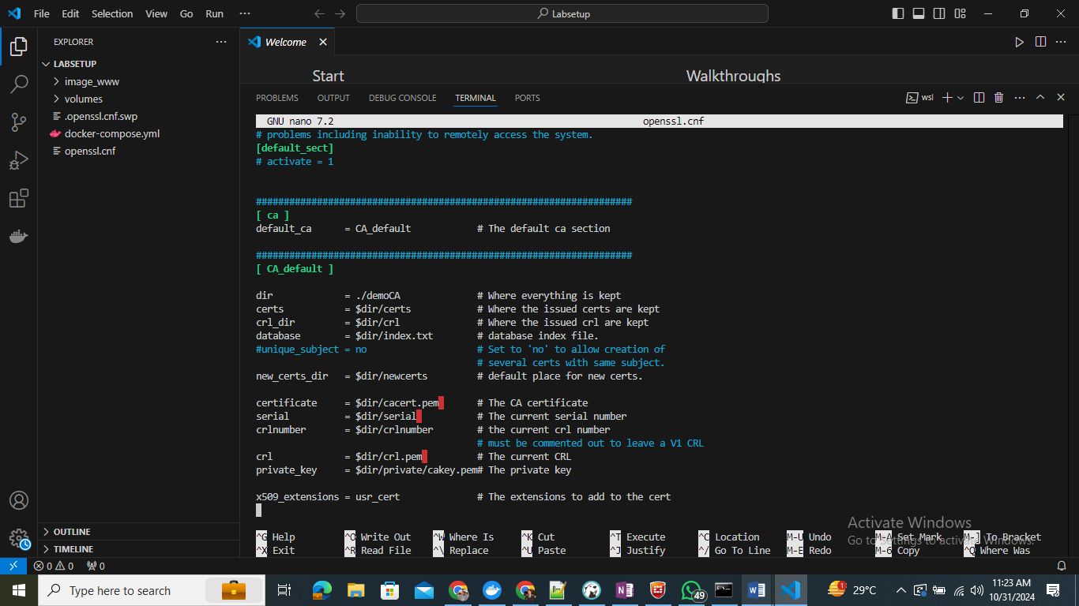
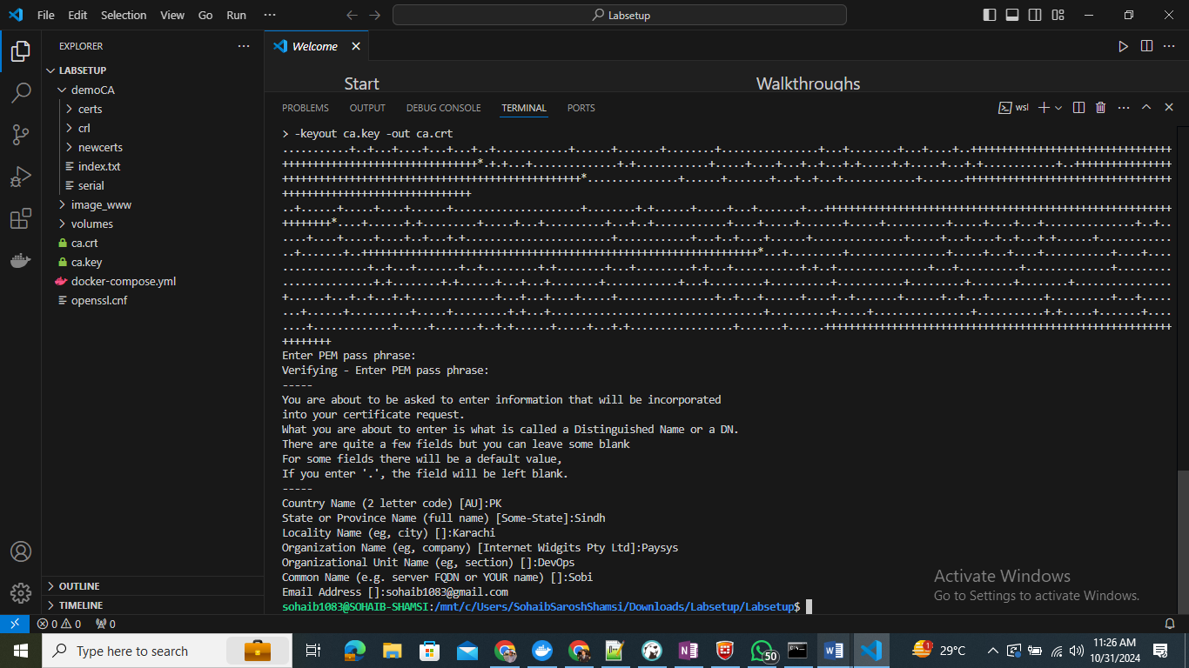
Certificate Content:
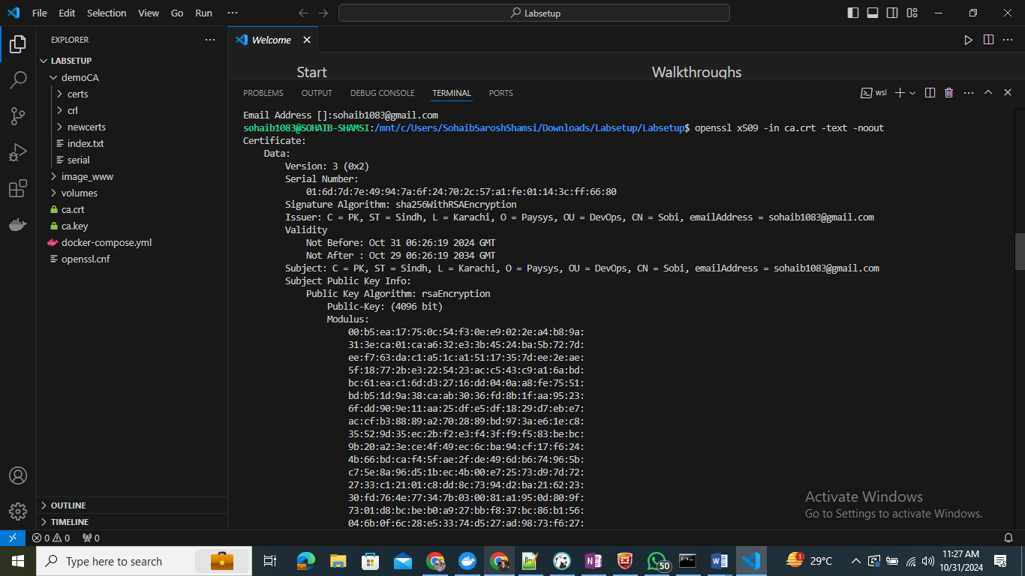
Private Key:
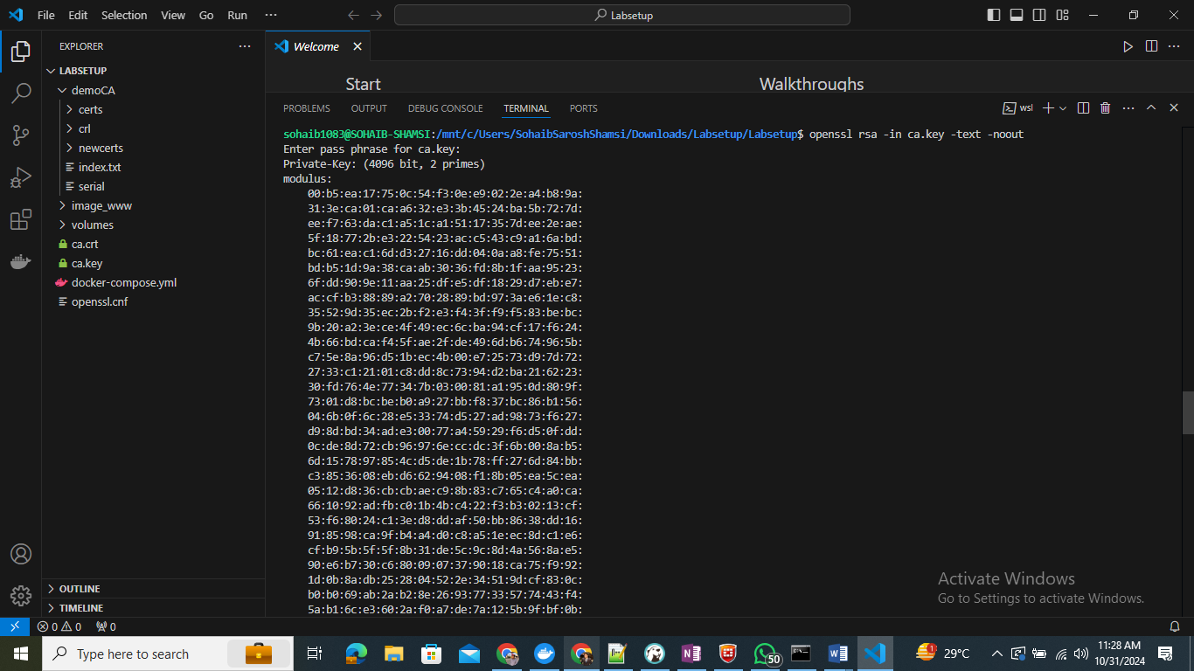
ca.key is your private key
ca.crt is the certificate

Task 2:

openssl req -newkey rsa:2048 -sha256 \
-keyout server.key -out server.csr \
-subj "/CN=shamsi-2024.com/O=Company Inc./C=US" \
-passout pass:sohaib1083
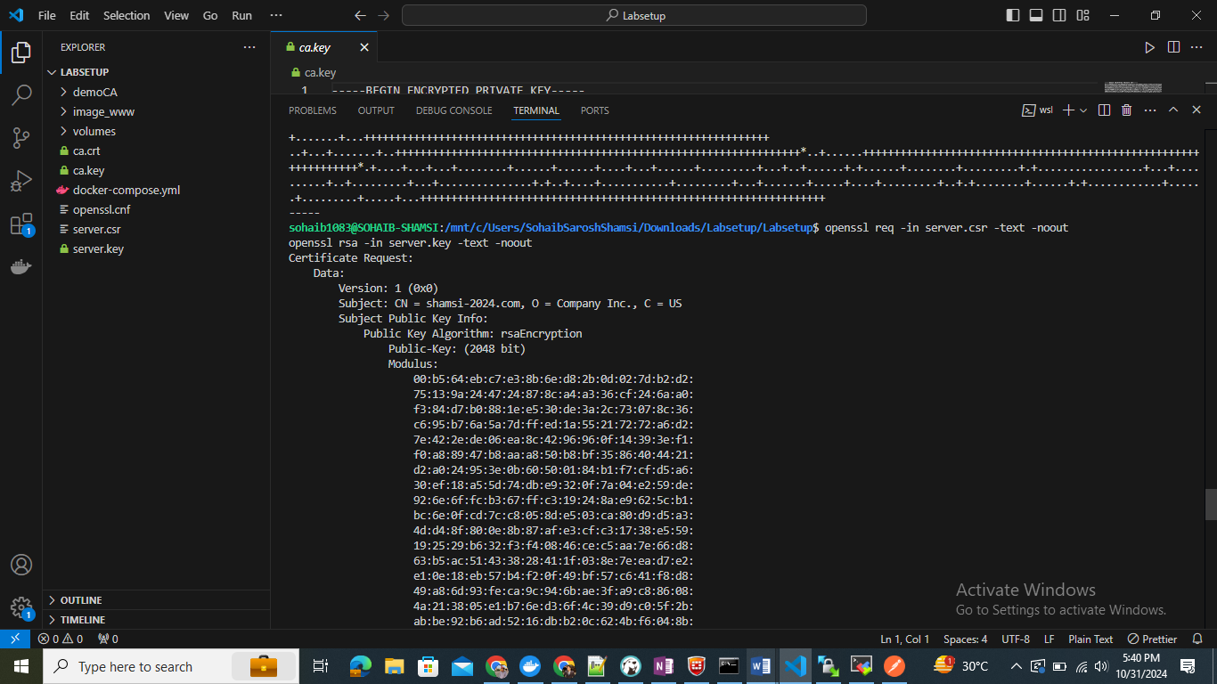
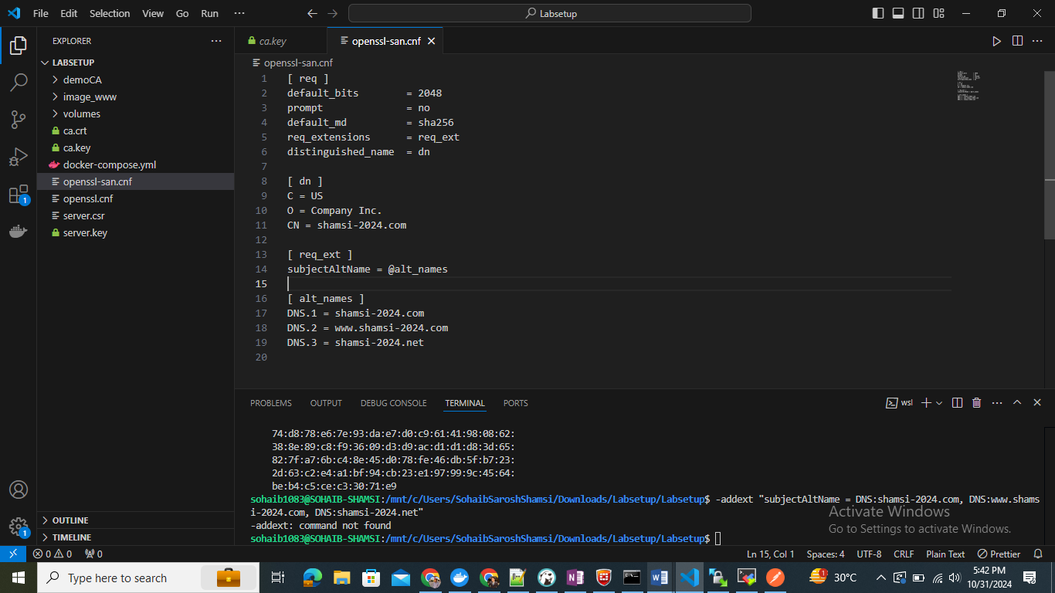
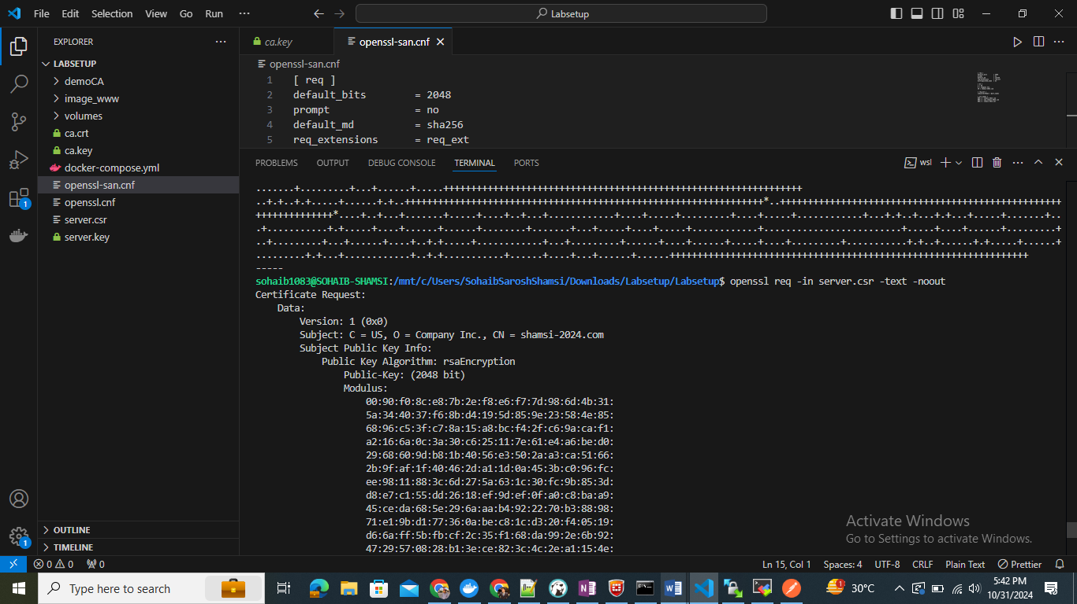

Task 3:
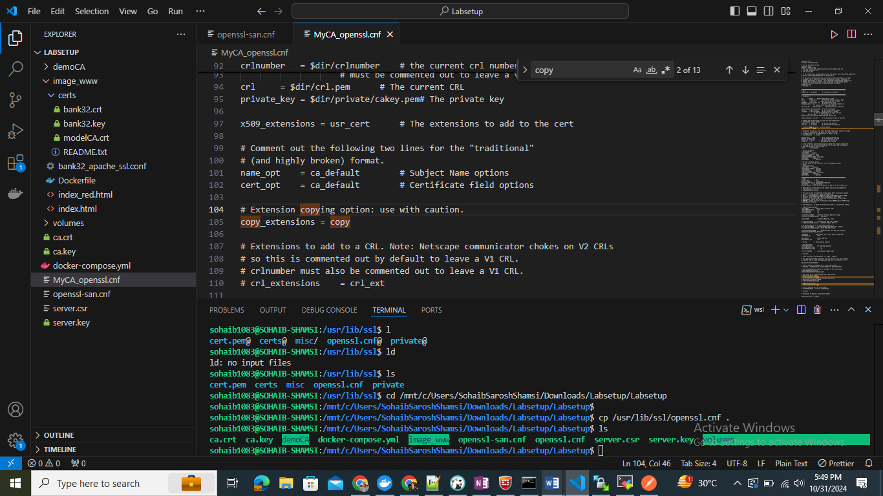
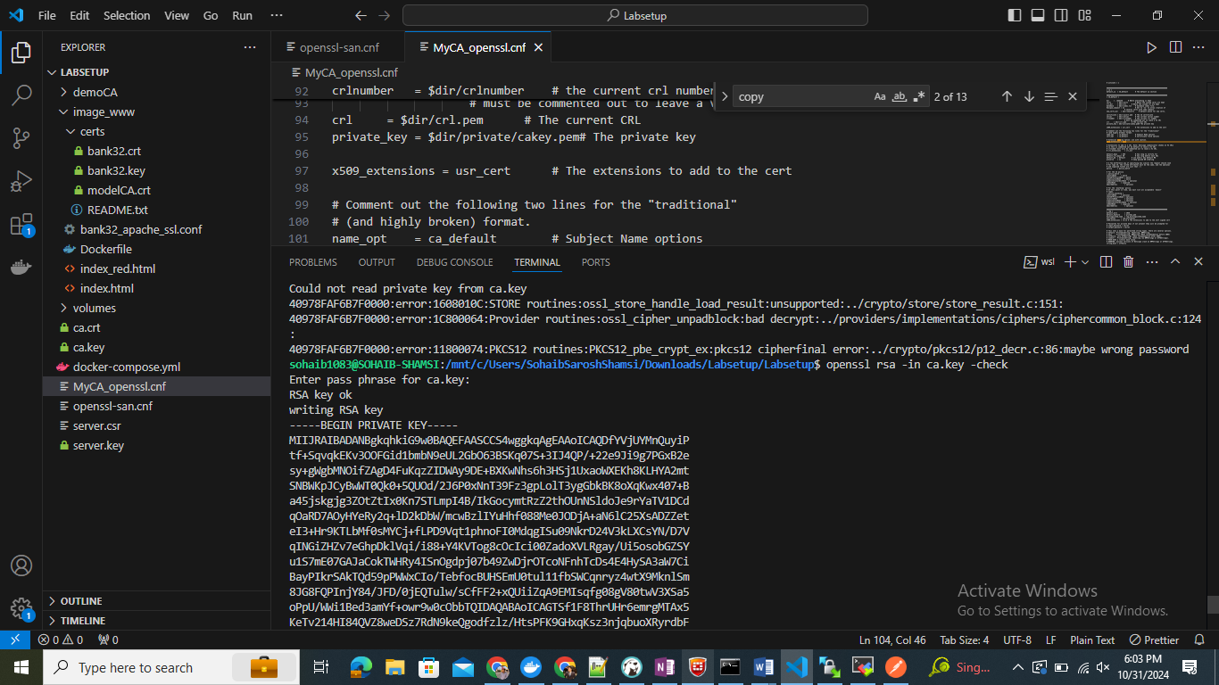
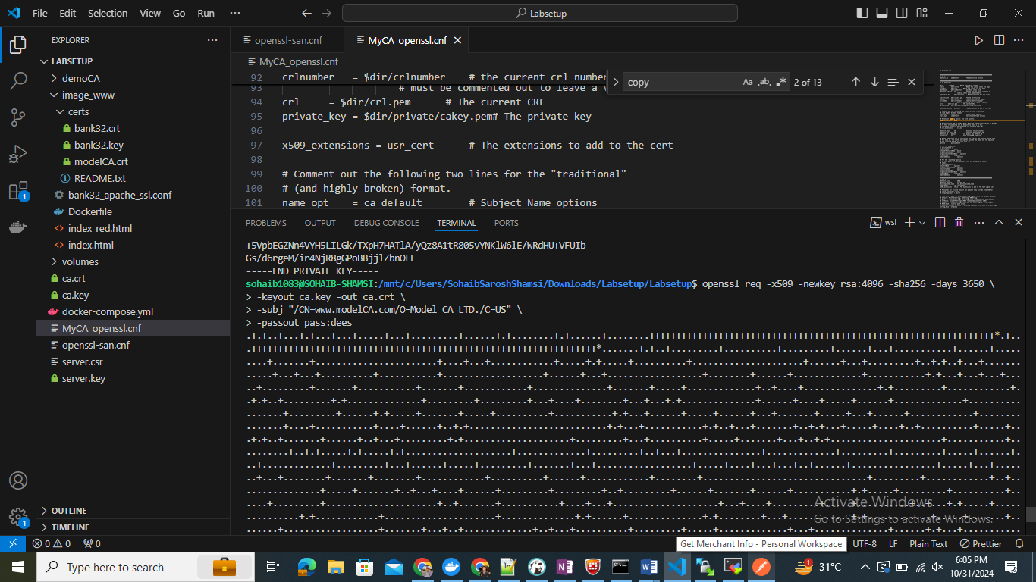
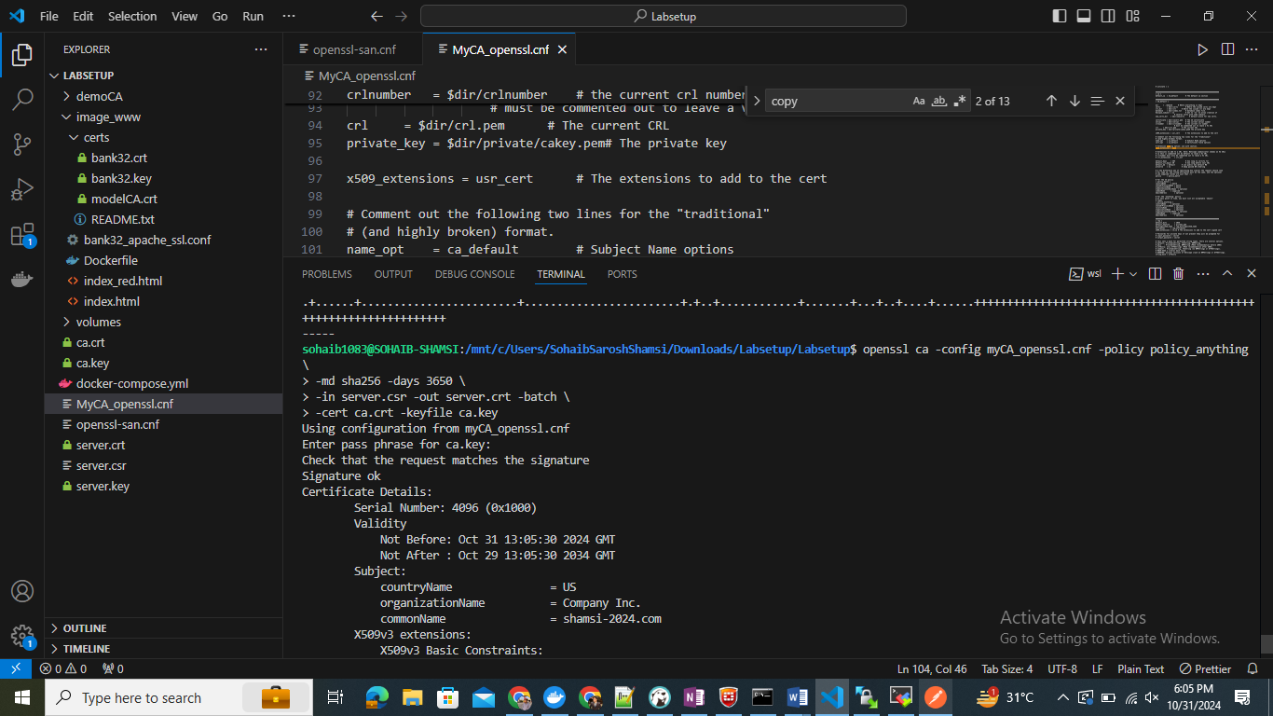

Task 4:
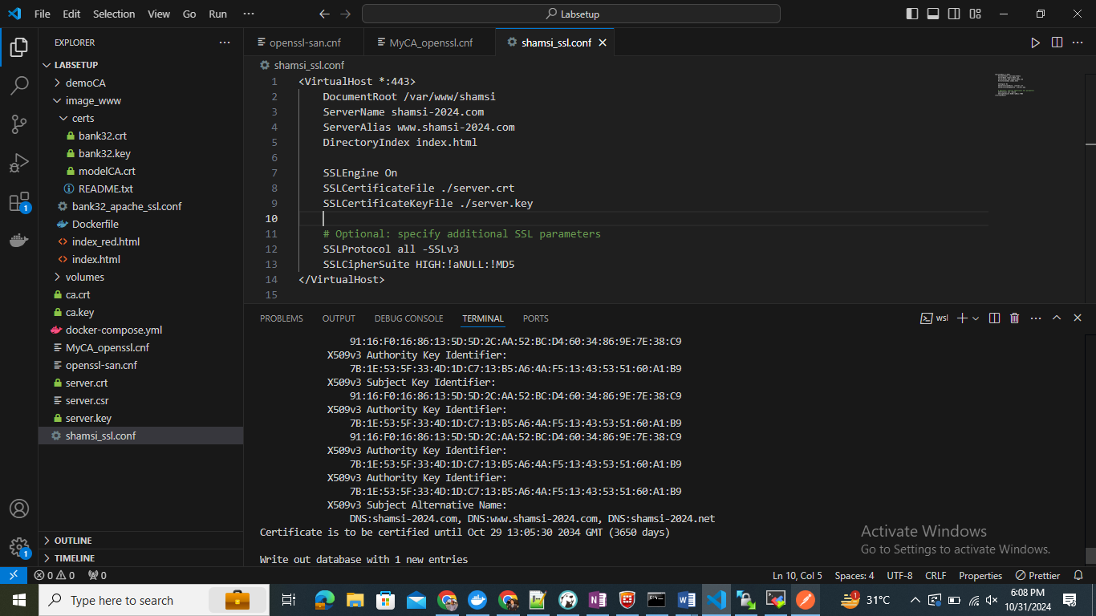
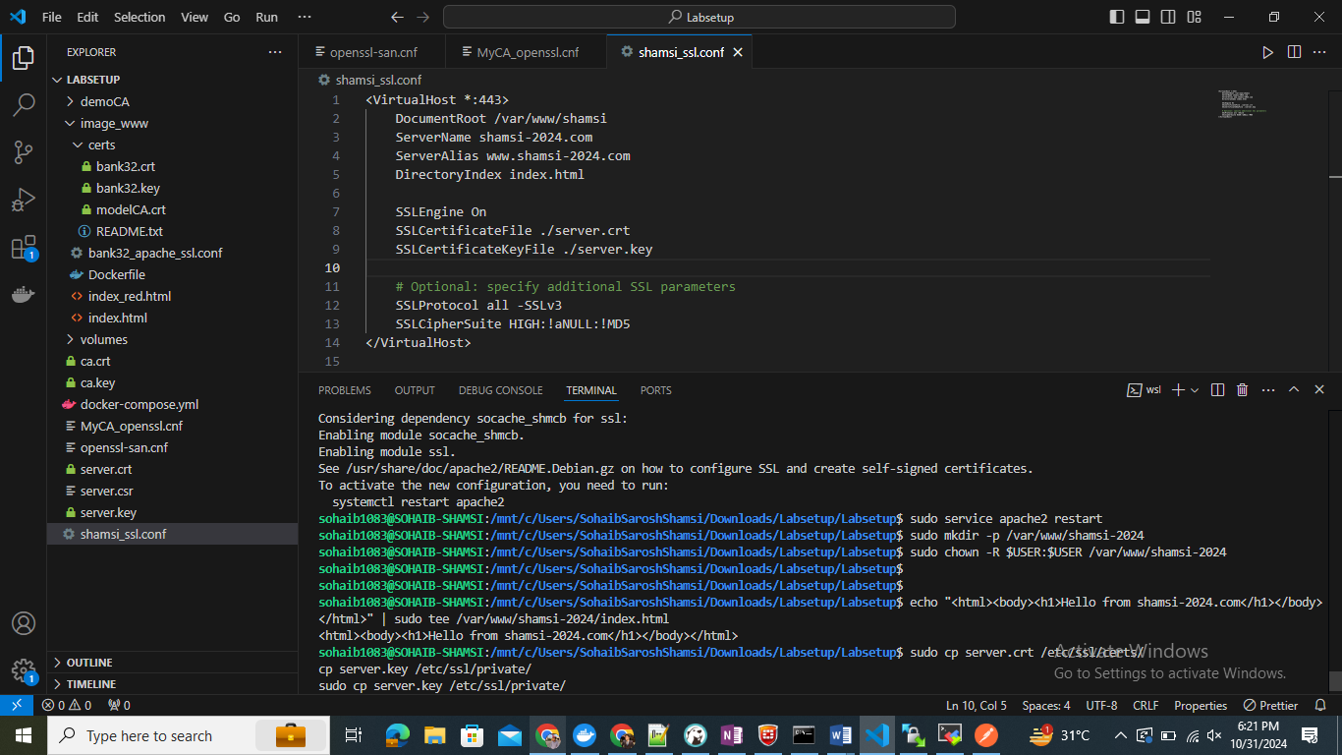
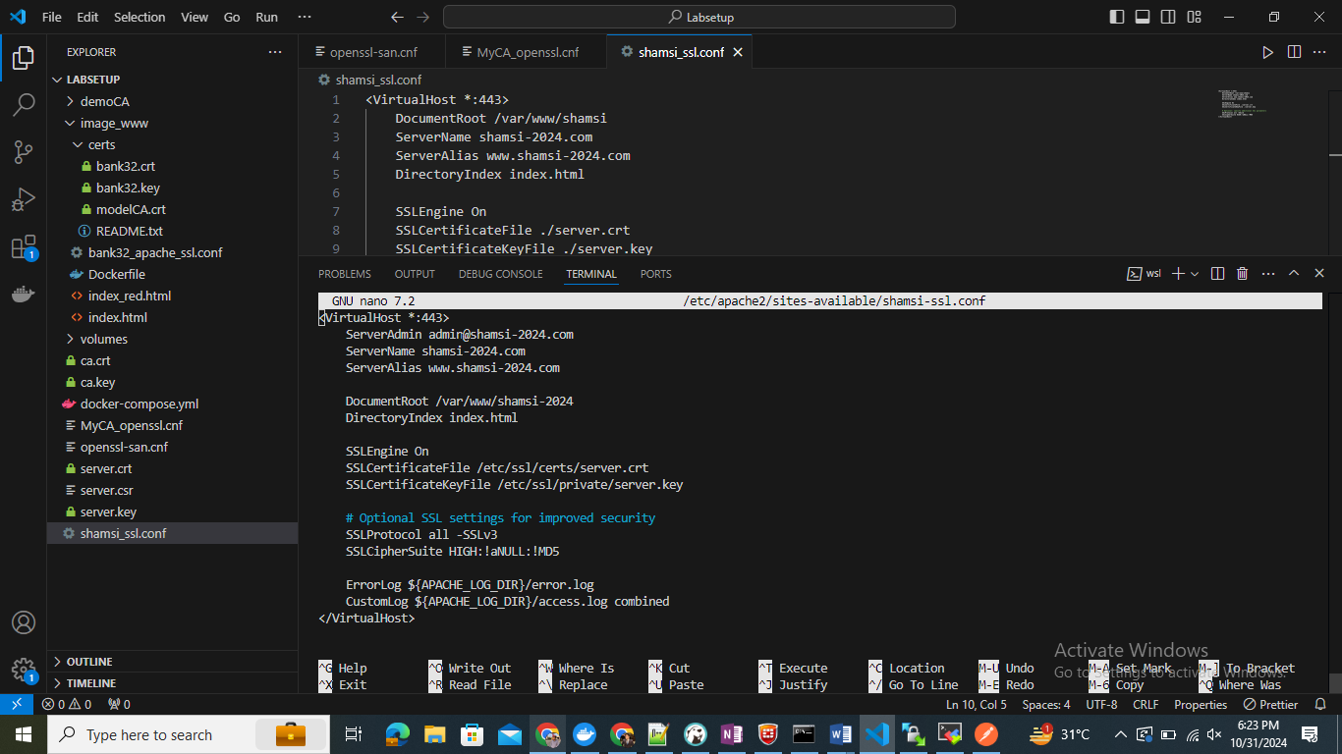
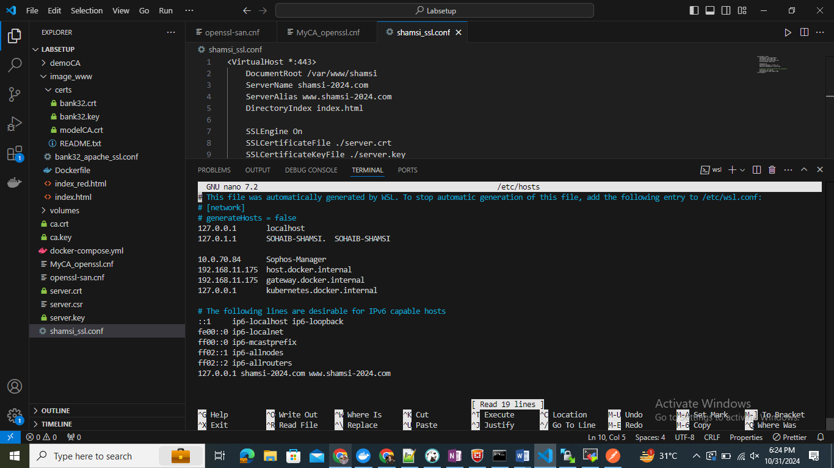

Task 5:
Create a New Virtual Host Configuration in Apache:
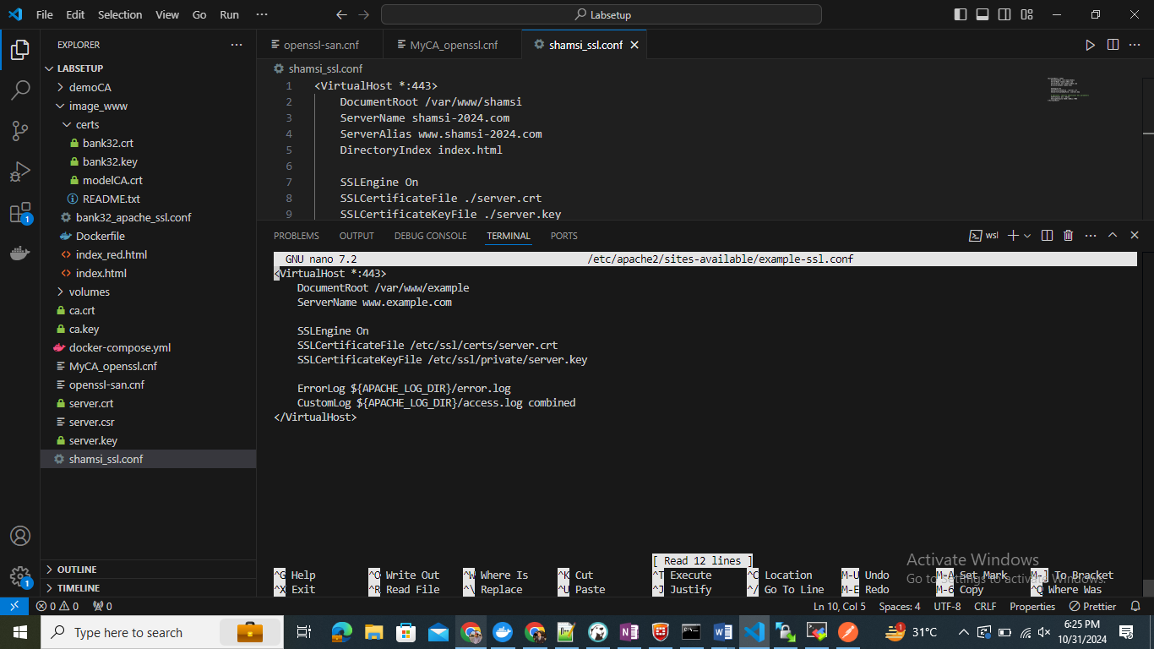
127.0.0.1 www.example.com
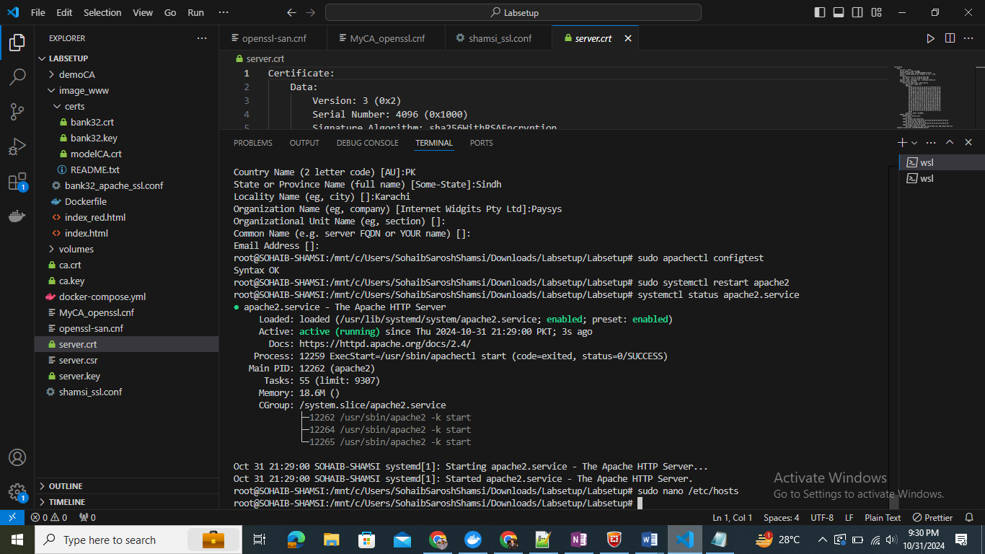
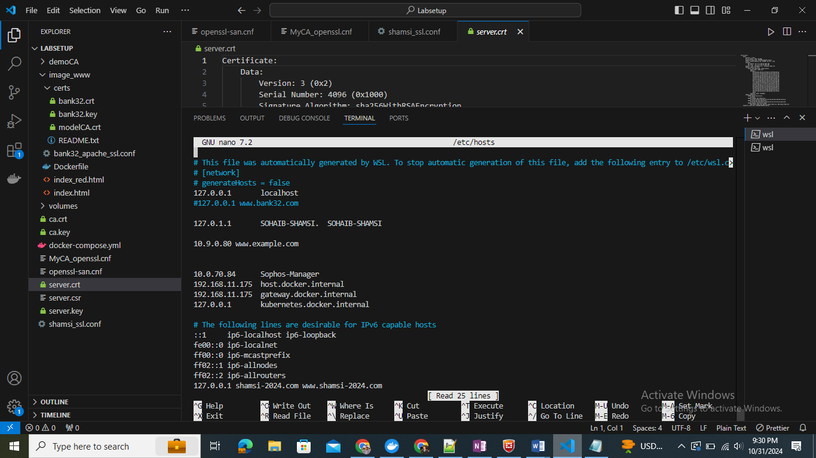
Save and close the file. Now, any requests to https://www.example.com from your machine will go to the fake Apache server you set up.
browsers shows a warning because the certificate for www.example.com is not trusted.

Task 6:
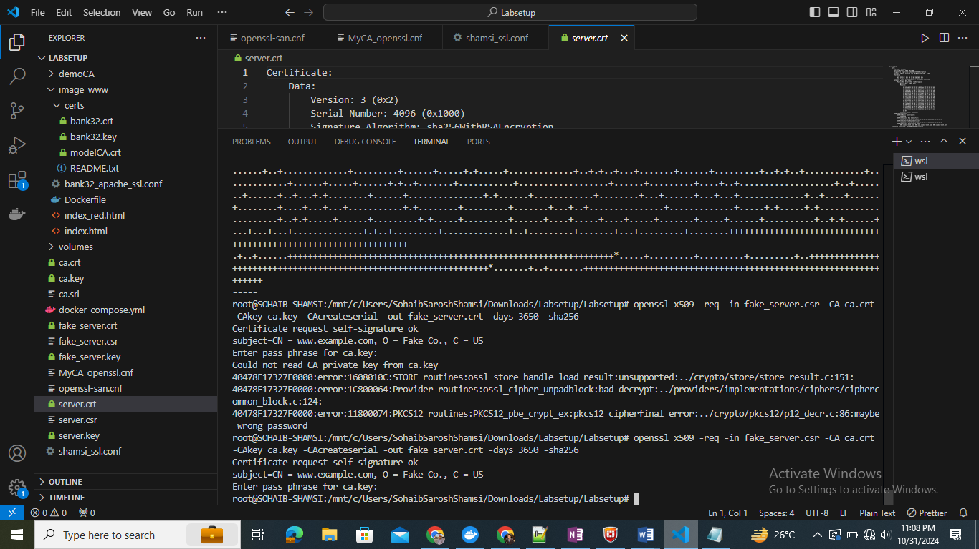
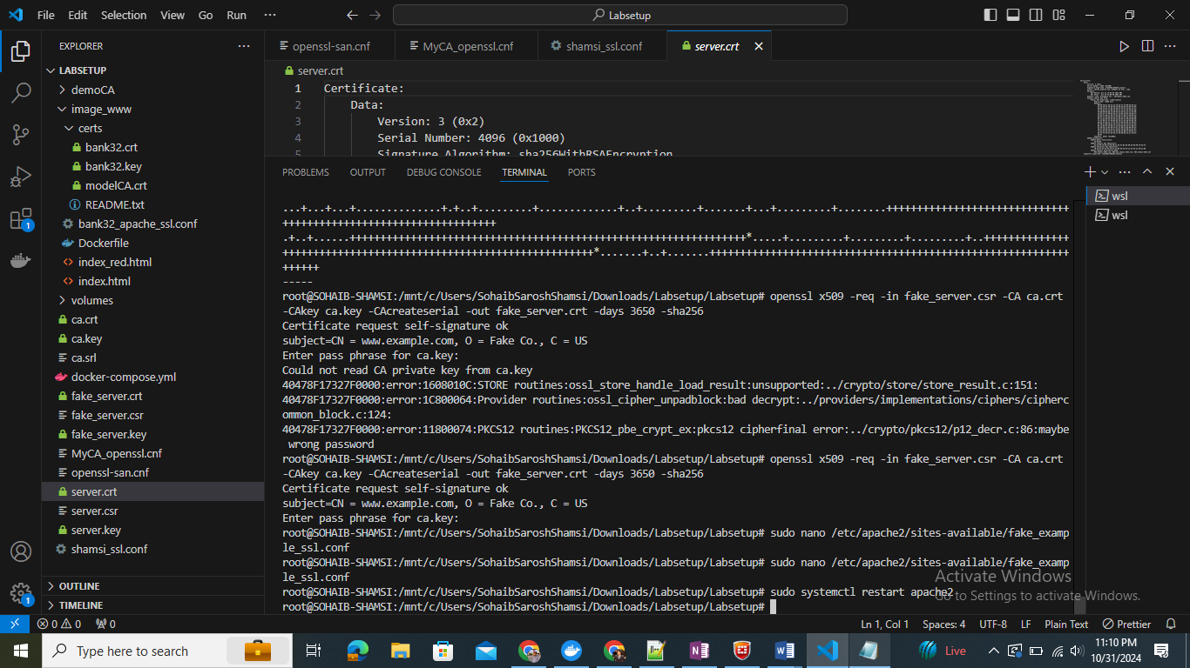
Since the certificate is signed by the compromised CA, the browser will accept it without warnings, making the MITM attack successful.

